ADVITI PVT. LTD. : HR ANALYTICS PROJECT

## A Data-Driven Approach to Workforce Stability and Productivity

* Problem Statement 1 : Identify factors influencing Employee Attrition .
* Problem Statement 2 : Enhance Employee Engagement

# Submitted to : Kalpesh Ghadigaonkar

**Submitted by : Mesha**

**TABLE OF CONTENTS**

|  |  |
| --- | --- |
| SNO. | CONTENT |
| 1. | Introduction |
| 2. | Objectives |
| 3. | Data Cleaning and Preparation |
| 4. | Analysis and Insights   * Important Note * Employee Attrition Analysis * Employee Engagement Analysis |
| 5. | Recommendations |

## INTRODUCTION

Employee attrition and engagement are crucial aspects of human resource management that impact organizational success. This report analyzes HR data to explore two key problems:

1. **Factors Influencing Employee Attrition** – Identifying the causes of employee turnover and recommending strategies to improve retention.
2. **Enhancing Employee Engagement** – Understanding what drives engagement and proposing ways to foster a motivated workforce.

The insights aim to help organizations improve workforce stability and productivity.

## OBJECTIVES

The project focuses on two primary objectives:

1. To uncover the key reasons behind employee turnover and develop evidence-based strategies to enhance retention.
2. To determine the factors driving employee engagement and suggest actionable measures to boost engagement across the organization.

## DATA CLEANING AND PREPARATION:

The initial dataset contained several missing values and discrepancies. Data cleaning involved:

1. For the **Gender , Position & Department** column, the values were updated to a more concise format for easier handling in future analyses. Specifically, the transformations were:
   * ‘F’ was replaced with ‘Female’ .
   * ‘M’ was replaced with ‘Male’.
   * ‘Account Exec.’ , ‘Account Executive’ , ‘AccountExec.’ & ‘AccountExecutive’ were replaced with ‘Account Executive’.
   * ‘DataAnalyst’ & ‘Data Analyst’ were replaced with ‘Data Analyst’ .
   * ‘Content Creator’ & ‘Creator’ were replaced with ‘Content Creator’ .
   * ‘Analytics Intern’ , ‘Intern’ & ‘SE Intern’ were replaced with ‘Interns’.
   * ‘ ‘ was replaced with ‘Management’ .

2 . For the purpose of more detailed analysis, the **Age , Salary , Training hours , Absenteeism & Distance from Work** columns were categorized into different groups. These categorizations were designed to facilitate subgroup analyses, enabling the identification of patterns or trends that might not be obvious when considering the entire data set .

#### a . Age Categories:

* + ‘<=20’
  + ‘21-25’
  + ‘2G-30’
  + ‘31-35’
  + ‘3G-40’
  + ‘41-45’
  + ‘4G-50’

#### Salary Categories:

* + ‘>50L’
  + ‘40L-50L’
  + ‘30L-40L’
  + ‘20L-30L’
  + ‘10L-20L’
  + ‘<10L’

#### Training Hours Categories:

* + ‘40+ hours’
  + ‘30-40 hours’
  + ‘20-30 hours’
  + ‘10-20 hours’
  + ‘<10 hours’

#### Absenteeism Categories:

* + ‘No Leaves’
  + ‘1-5 days’
  + ‘G-10 days’
  + ‘11-15 days’
  + ‘15+ days’

#### Distance from Work Categories:

* + ‘40+ km’
  + ‘30-40 km’
  + ‘20-30 km’
  + ‘10-20 km’
  + ‘<10 km’

1. Combined all Job Satisfaction and Employee Benefit Satisfaction related columns into

**Job_Satisfaction_rate** and **Employee_Benefit_Satisfaction_rate.**

# Analysis and Insights:

**Important Note**

**For the purpose of better analysis and more accurate insights, interns have been excluded from the data. This ensures that the findings reflect trends and patterns relevant to full-time employees only.**

### Employee Attrition Analysis :

1. Attrition Rates



* + Attrition Rate is 48.4% .

1. Department-wise Attrition Rates

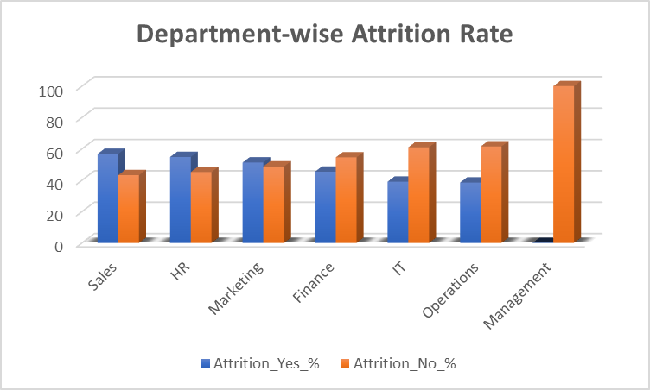

* + The Sales Department has the highest Attrition rate of 56.7% , Followed by HR at 54.7% .
  + The Operations Department has the lowest attrition rate at 38.4%.
  + Management includes CEO & COO .

1. Position-wise Attrition Rates

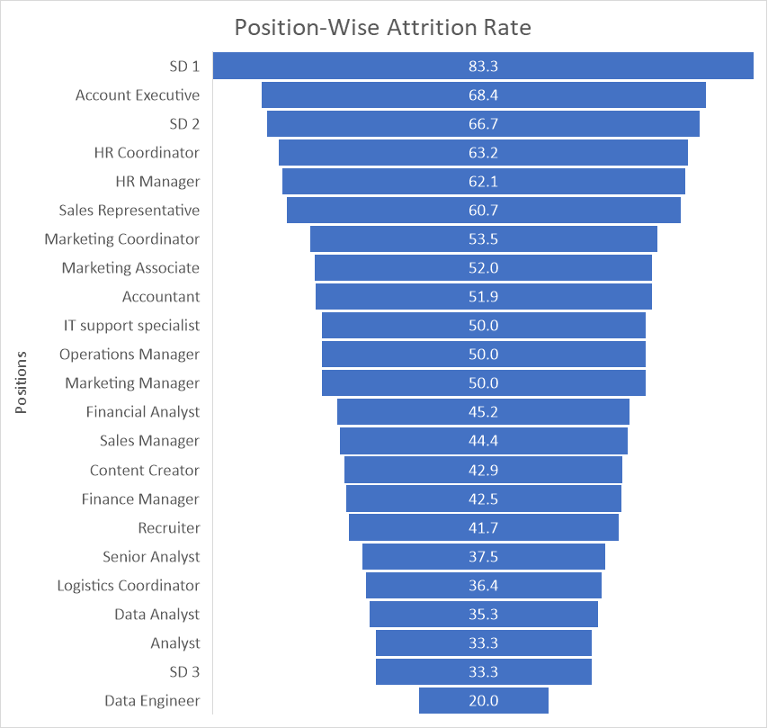

* + The positions with the highest attrition rates are SD 1 (83.3%) and Account Executive (68.42%) , followed by SD 2 (66.66%) . Immediate attention is needed to understand why these roles are experiencing such high attrition.
  + The Data Engineer position has the lowest attrition rate at 20%, followed by the SD 3 at 33.33%. These roles seem to have higher job stability.
  + Positions such as **IT Support Specialist** and **Marketing Manager** show equal attrition and retention percentages (50%), highlighting mixed employee experiences in these roles.
  + Positions that come under the HR Department ( HR Coordinator & HR Manager ) show relatively high Attrition rate of ( 63% & 62%) respectively , indicating potential challenges such as role dissatisfaction, workload stress, or limited career advancement opportunities.
  + **Financial Analyst** (45.16%) and **Sales Manager** (44.44%) also exhibit noticeable turnover rates.

1. Gender-wise Attrition Rate

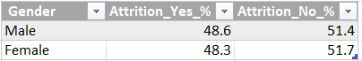

* + Attrition Rates for both genders are same i.e 48% depicts there is no effect of gender on Attrition rate.

1. AgeGroup-wise Attrition rate

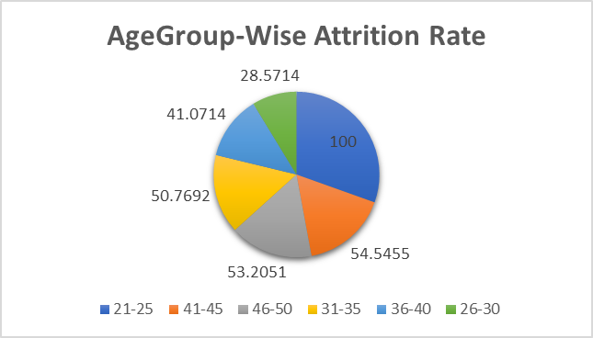

* + Age Group of 21-25 (100%) and 41-45 (54.5%) has the highest Attrition rate , followed by 46-50 (53.2%) .
  + Younger employees (21-25) have the highest attrition, highlighting a need for stronger retention strategies for entry-level workers.
  + Mid-career employees (41-50) also show significant turnover, likely tied to stagnation or external opportunities.
  + Older and more stable employees (26-40) exhibit lower attrition, indicating better satisfaction in this group.

1. Year of Service-wise Attrition rate

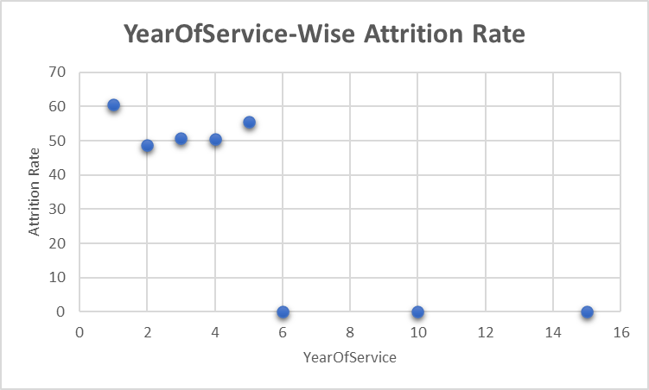

* + People with 1 year of service who fall under the 21-25 Age Group have the highest Attrition rate , followed by 5 years of service employees .
  + 1 year : High attrition at this stage suggests **onboarding issues**, **misaligned expectations**, or lack of early engagement.
  + 5 year : Attrition at this point often reflects **career stagnation**, lack of **promotion opportunities**, or dissatisfaction with **compensation and benefits**.

1. Distancefromwork-wise Attrition rate

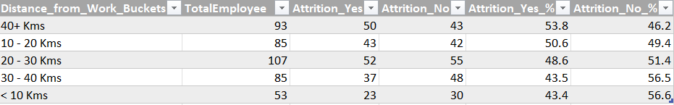

* + Employees who have Distance from work 40+ km and 10-20 km have the highest Attrition rate of 53.7% and 50.5% respectively.

1. Distance from work and Job Satisfaction Rate wise Attrition rate

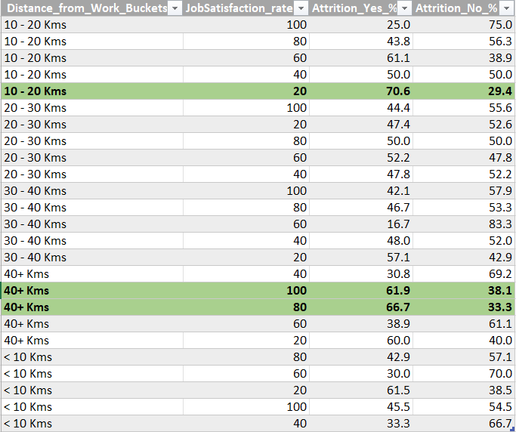

* + Employees who are 10-20 km away from work have an Attrition rate of 70% because of low job satisfaction rate i.e 20%.
  + Employees who are 40+ km away from work have a high Job satisfaction rate but still left the company due to long distance from work .

1. Promotion and Year of Service wise Attrition rate

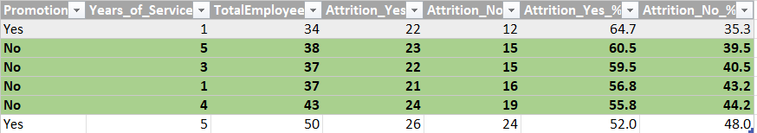

* + Employees who are working from 3-5 years in a company, don’t get promoted , indicating lack of career progression.

1. Age Group , Salary and Year Of Service wise Attrition rate

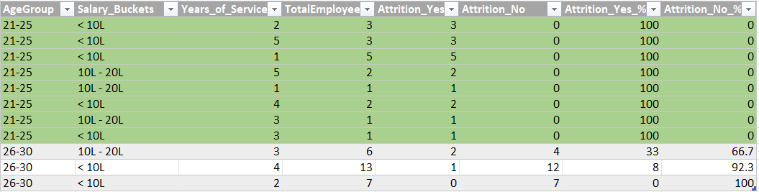

* + Age Group 21-25 : Employees are working from more than 2 years , hence Salary compensation could be reason for attrition.

1. Department and Job Satisfaction wise Attrition rate

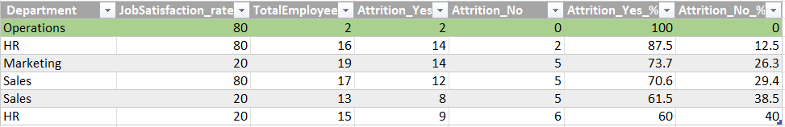

* + Operations and HR has the highest Job Satisfaction rate as well as Attrition rate .

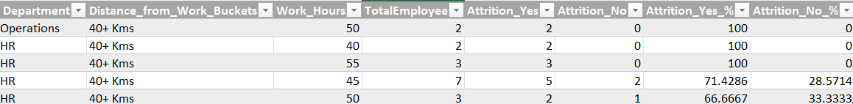

* + Employees from Operations and HR department are 40+km away from work as well as working hours more than 40 h leads to work load .

1. Performance Rating wise Attrition Rate

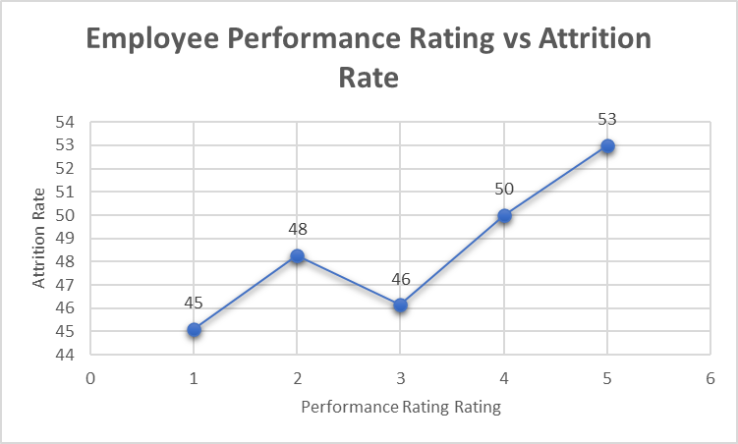

* + High Performing Employees have the highest Attrition rate indicating immediate attention towards it .

1. Performance Rating , Promotion , Year of Service wise Attrition rate

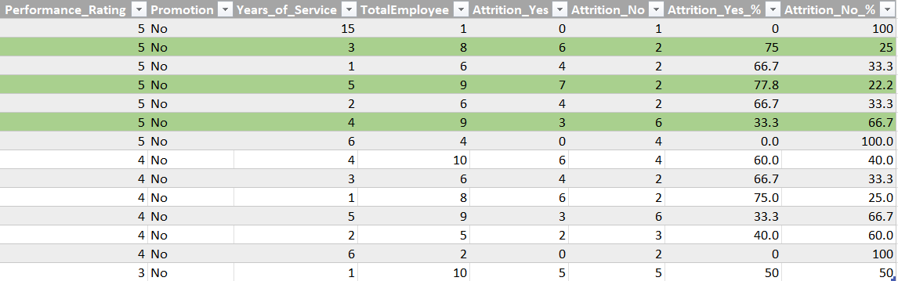

* + Employees who are working from 3-5 years and not getting promotion as they are giving their best leads to loose interest in the job and increase in Attrition rate .
  + Increase in Attrition rate also affected by workload on these employees.

### Enhance Employee Engagement :

1. Employee Engagement Score:

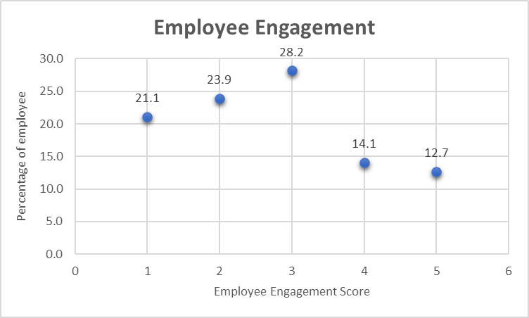

* + Employee Engagement Score is 3 .
  + Low scores should be tackled by Strengthen the company culture and support systems.

1. Job Satisfaction rate wise Employee Engagement:

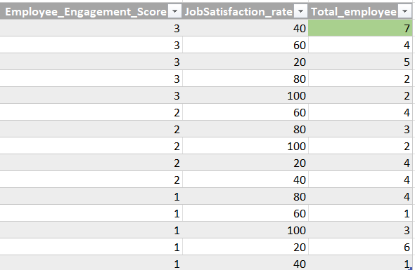

* + Low job satisfaction leads to low employee engagement , indicating immediate attention towards it .

1. Promotion wise Employee Engagement

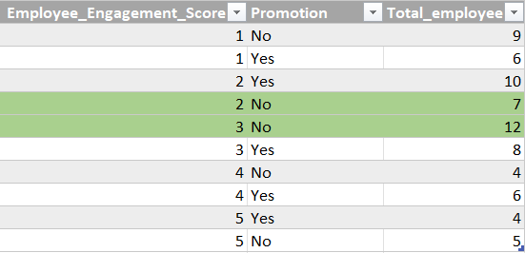

* + Lack of Career Progression leads to low employee engagement as well as leads to Attrition too.

1. Salary Range and Year of Service wise employee engagement score

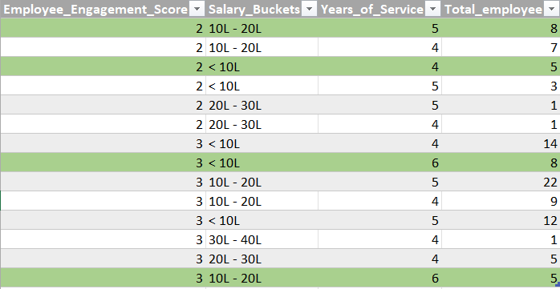

* + Employees with a low engagement score have a salary range less than 10L and between 10L-20L though they are working from more than 4 years.

## Recommendations

#### Onboarding Programs

Strengthen onboarding for new hires, particularly in the 21-25 age group, by providing clear role expectations, regular feedback, and mentoring.

#### Career Progression

Develop structured career development plans and promotion pathways for employees with 3-5 years of service, focusing on high performers.

#### Workload Management

Reassess workloads in departments like HR and Operations, offering stress management programs and flexible working options.

#### Compensation and Benefits

Review salary structures, particularly for employees earning less than ₹10L annually, and introduce performance-based bonuses.

#### Training and Upskilling

Provide training opportunities for roles with high attrition, such as SD1 and Account Executive, and sponsor professional certifications.

#### Job Satisfaction

Conduct regular satisfaction surveys and take proactive steps to improve employee experiences, particularly in departments with mixed feedback.

#### Commute Challenges

Offer remote or hybrid work options for employees living 40+ km from work, or provide transportation allowances and support.

#### Employee Recognition

Celebrate employee achievements through regular awards, recognition events, and peer-to-peer appreciation initiatives.

#### Retention Programs for Tenured Employees

Provide opportunities like sabbaticals, advanced training, and rotational programs for employees with over 5 years of service.

#### Role Redesign

Analyze high-attrition roles such as SD1 and SD2 to identify and address challenges, redesigning roles to reduce turnover.

#### Sales and HR Engagement

Focus on improving engagement in these departments through team bonding activities and addressing workload challenges.

#### Work-Life Balance

Promote flexible work hours, encourage time off, and limit overtime to prevent burnout and improve satisfaction.

#### Employee Feedback

Use surveys and feedback platforms to gather insights, act on suggestions, and communicate improvements to employees.

#### Leadership Development

Create leadership programs for high performers, involving them in strategic projects and offering growth opportunities.

#### Diversity and Inclusion

Ensure equitable opportunities for growth across all demographics, focusing on fostering an inclusive workplace culture.

#### Attrition and Engagement Metrics

Track metrics like job satisfaction, attrition, and engagement by department and role to identify and address specific issues.

#### Entry-Level Retention

Focus on retaining younger employees (21-25 age group) through competitive compensation and clearer career paths.

#### Transportation Support

Provide commute assistance like shuttle services or travel reimbursements for employees with long commutes.

#### Transparent Communication

Ensure clarity in promotion criteria, compensation, and workload expectations to build trust among employees.

#### Positive Work Culture

Strengthen workplace culture with regular team-building activities, open communication, and celebration of milestones.